#### 计算机视觉实践-练习1

学号：122106222783 姓名：王心怡

1 实验目标

·理解关键点检测算法DOG原理。

·理解尺度变化不变特征SIFT。

·采集一系列局部图像，自行设计拼接算法。

·使用Python实现图像拼接算法。

2 实现说明

**·从SIFT中检测特征和关键点**

def Detect_Feature_And_KeyPoints(self, image):

gray = cv2.cvtColor(image, cv2.COLOR_BGR2GRAY)

# 从图像中检测和提取特征

descriptors = cv2.SIFT_create()

(Keypoints, features) = descriptors.detectAndCompute(image, None)

Keypoints = np.float32([i.pt for i in Keypoints])

return (Keypoints, features)

**·得到有效匹配点**

def matchKeypoints(self, KeypointsA, KeypointsB, featuresA, featuresB,lowe_ratio, max_Threshold):

AllMatches = self.get_Allpossible_Match(featuresA,featuresB);

valid_matches = self.All_validmatches(AllMatches,lowe_ratio)

if len(valid_matches) > 4:

# 构造两组点

pointsA = np.float32([KeypointsA[i] for (_,i) in valid_matches])

pointsB = np.float32([KeypointsB[i] for (i,_) in valid_matches])

(Homograpgy, status) = self.Compute_Homography(pointsA, pointsB, max_Threshold)

return (valid_matches, Homograpgy, status)

else:

return None

def get_Allpossible_Match(self,featuresA,featuresB):

# 使用欧氏距离和opencv计算所有匹配

match_instance = cv2.DescriptorMatcher_create("BruteForce")

All_Matches = match_instance.knnMatch(featuresA, featuresB, 2)

return All_Matches

def All_validmatches(self,AllMatches,lowe_ratio):

# 根据lowe概念获取所有有效匹配

valid_matches = []

for val in AllMatches:

if len(val) == 2 and val[0].distance < val[1].distance * lowe_ratio:

valid_matches.append((val[0].trainIdx, val[0].queryIdx))

return valid_matches

def Compute_Homography(self,pointsA,pointsB,max_Threshold):

# 使用两幅图像中的点计算单应性

(H, status) = cv2.findHomography(pointsA, pointsB, cv2.RANSAC, max_Threshold)

return (H,status)

**·计算单应性获得图像的透视图**

def getwarp_perspective(self,imageA,imageB,Homography):

val = imageA.shape[1] + imageB.shape[1]

result_image = cv2.warpPerspective(imageA, Homography, (val , imageA.shape[0]))

return result_image

**·可视化关键匹配点**

def draw_Matches(self, imageA, imageB, KeypointsA, KeypointsB, matches, status):

(hA,wA) = self.get_image_dimension(imageA)

vis = self.get_points(imageA,imageB)

# 在匹配点上循环

for ((trainIdx, queryIdx), s) in zip(matches, status):

if s == 1:

ptA = (int(KeypointsA[queryIdx][0]), int(KeypointsA[queryIdx][1]))

ptB = (int(KeypointsB[trainIdx][0]) + wA, int(KeypointsB[trainIdx][1]))

cv2.line(vis, ptA, ptB, (0, 255, 0), 1)

return vis

3 结果截图

原始图像：

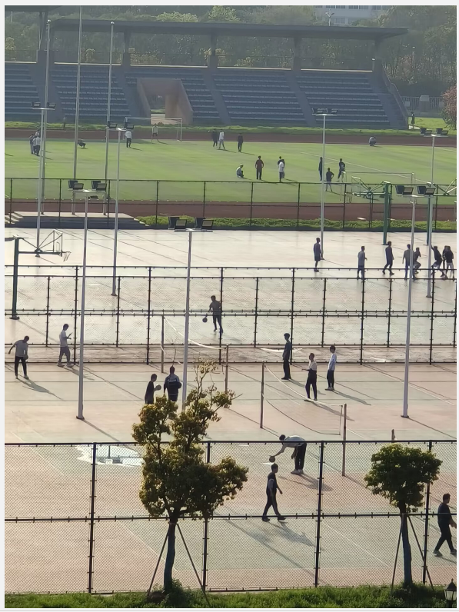 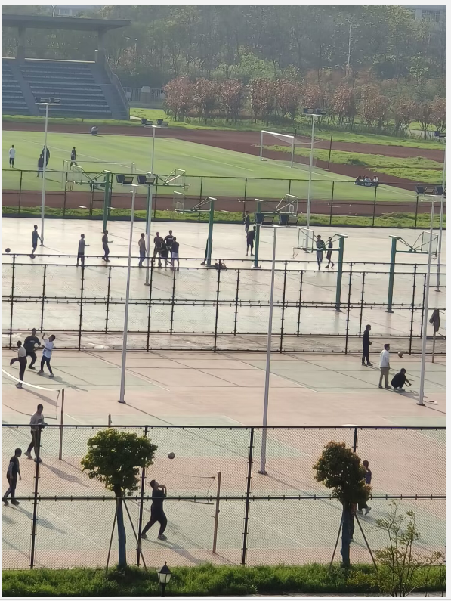 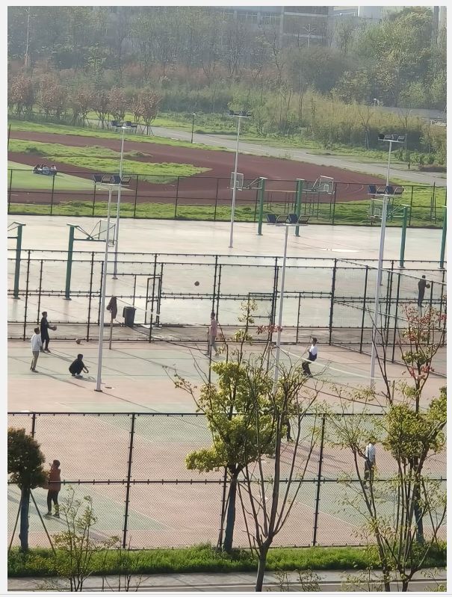 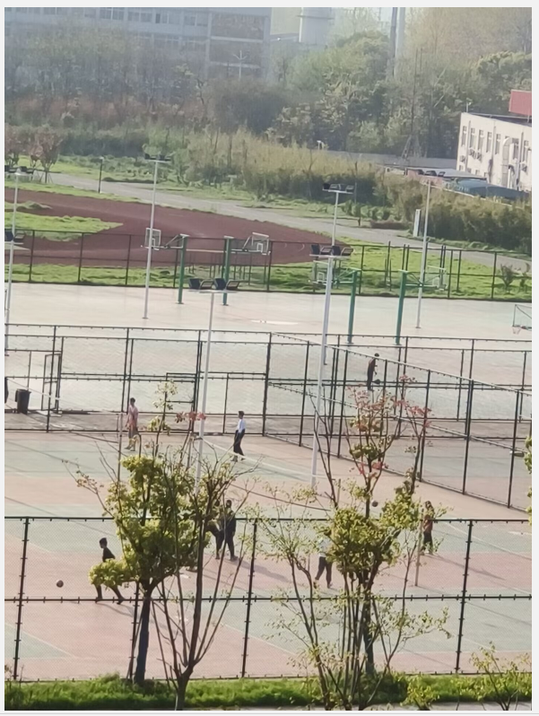

匹配点：

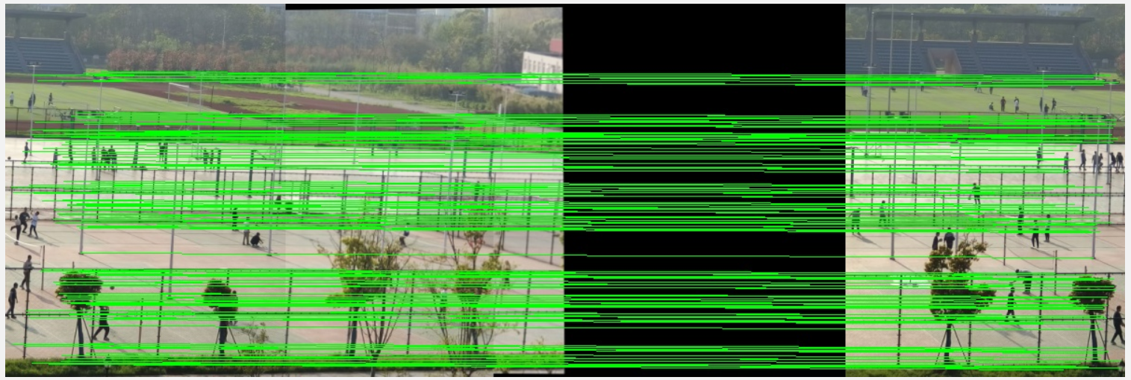

拼接结果：

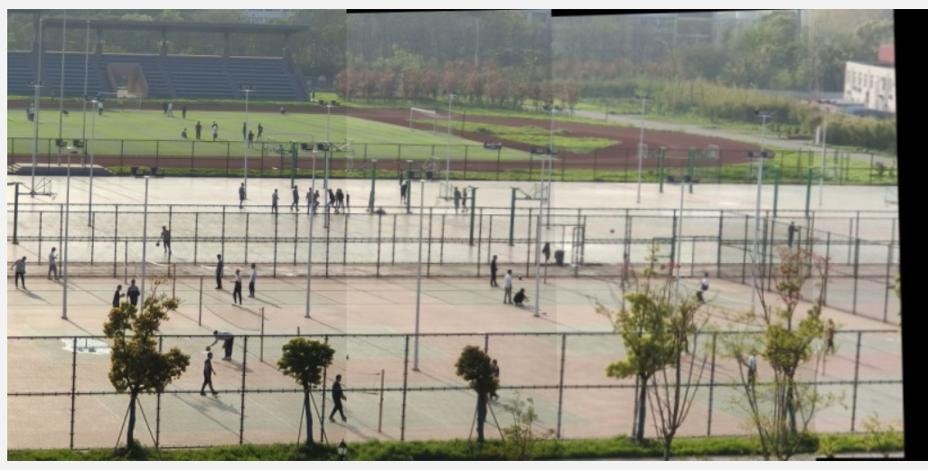

4 运行说明

·将需要拼接的图像放在main.ipynb所在文件下，运行main.ipynb，根据提示输入图像数目和图像名称。

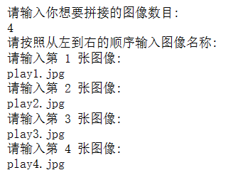

·待程序运行完后，文件夹里会出现2个运行结果，分别为匹配点Matched_points.jpg和拼接得到的全景图像Panorama_image.jpg。

